
SRM Institute of Science and Technology
BATCH 1/SET A

College of Engineering and Technology
DEPARTMENT OF ECE
SRM Nagar, Kattankulathur – 603203, Chengalpattu District, Tamilnadu
Academic Year: 2022-23 (EVEN)
Test: CLAT-3 Date: 03/05/2023
Course Code & Title: 18ECE221T Radar and Navigational Aids Duration: 08.00 A.M – 09.40 AM
Year & Sem: III Year/ VI Sem Max. Marks: 50
Course Articulation Matrix:
S.NO | 18ECE221T- Radar and Navigational Aids | Program Outcomes (PO) |  |  |  |  |  |  |  |  |  |  |  | Program Specific outcomes (PSO)
S.NO | Course Outcomes (CO) | 1 | 2 | 3 | 4 | 5 | 6 | 7 | 8 | 9 | 10 | 11 | 12 | 1 | 2 | 3
1 | Describe the principle operation of radar with the help of range equation and parameters | 3 | 2 | - | - | - | - | - | - | - | - | - | - | - | - | -
2 | Apply Doppler principle to radars and hence comprehend the features of different types of radar | 3 | 2 | - | - | - | - | - | - | - | - | - | - | - | - | -
3 | Analyze the reception of Radar signals under noise and different propagation modes | 2 | - | - | 3 | - | - | - | - | - | - | - | - | - | - | 1
4 | Illustrate the functions of various parts of Radar transmitters and Receivers | 3 | 2 | - | - | - | - | - | - | - | - | - | - | - | - | -
5 | Outline the principle of navigation with aids of various navigation systems | 3 | - | - | 2 | - | - | - | - | - | - | - | - | - | - | 1

Part - A
(10 x 1 = 10 Marks)
Instructions: Answer all
Q. No | Question | Marks | BL | CO | PO
1 | Frequency of Klystron can be varied mechanically by having __________ in resonant cavities  A. Flexible walls B. Knob C. Potentiometer D. Piston | 1 | 1 | 4 | 1
2 | Silicon bipolar transistor are optimally used at lesser than  A. 4 GHz B. 6 GHz C. 3 GHz D. 5 GHz | 1 | 1 | 4 | 1
3 | Calculate the equivalent noise temperature of a microwave receiver operating at an ambient temperature of 290 K given the overall Noise Figure of the amplifier is 1.02.  A. 4.2 K B. 2.8 K C. 8.4 K D. 5.8 K | 1 | 2 | 4 | 2
4 | The preferred magnetron mode of operation is  A. π/2 mode B. π/4 mode C. 3π/2 mode D. π mode | 1 | 1 | 4 | 1
5 | Select the display type that is intensity modulated and rectangular coordinate with range indicated in horizontal axis and height as the vertical coordinate  A. PPI B. A scope C. RHI - display D. CRT display | 1 | 1 | 4 | 1
6 | NAVSTAR is a  A. 2 segment GPS B. 3 segment GPS C. 4 segment GPS D. 1 segment GPS | 1 | 1 | 5 | 4
7 | Pick the correct operating frequency range of DECCA  A. LF band B. HF band C. VHF band D. UHF band | 1 | 1 | 5 | 4
8 | ________antenna is used for direction finding at low and medium frequencies.  A. Horn B. Patch C. loop D. slot | 1 | 1 | 5 | 1
9 | What is the inclination of the glide slope with respect to the moving flight deck?  A. 3° B. 5° C. 3.5° D. 4° | 1 | 1 | 5 | 1
10 | ____________ is designed to eliminate Polarization Errors  A. Radio Compass B. Polarization C. Adcock D. Servo motor | 1 | 1 | 5 | 4
Part – B (4 x 4 = 16 Marks)
Section B1
Instructions: Answer ANY 2 Questions
11 | Discuss the various solid state sources used in RADAR | 4 | 2 | 4 | 1
12 | Determine the internal noise power of a microwave amplifier operating with a bandwidth of 300 MHz and a specified noise figure of 4 dB. | 4 | 2 | 4 | 2
13 | Evaluate the overall noise figure and equivalent noise temperature of a three stage cascaded network operating at an ambient temperature of 17 ͦ C with the following specifications  Stage 1: Gain = 30 dB, Te = 5K  Stage 2: Gain = 20 dB, F₂ = 4  Stage 3: Gain = 40 dB, F₂ = 16 | 4 | 3 | 4 | 2
Section B2
Instructions: Answer ANY 2 Questions
14 | Draw the block diagram of DECCA receiver | 4 | 1 | 5 | 1
15 | A radar receiver (P) receives signals from two transmitting stations (A & B). Derive the line of equation governing the transmission form the transmitting stations assuming that the time delay is constant | 4 | 3 | 5 | 2
16 | Describe the operation of secondary navigation system with necessary diagram. | 4 | 2 | 5 | 4
Part – C
(2 x 12 = 24 Marks)
Instructions: Answer any two (out of four)
17 | - Ornate the importance of Magnetron and explain the operation of the same.  (OR)  b) Explain the various types of duplexers and mixers used in RADAR receivers | 12 | 3 | 4 | 1
19 | a) Elaborate the operation of Radio Compass receiver. Justify the implications of two different antennas used in the above said receiver  (OR)  b) Investigate the Navigation process inducted by Global Positioning System (GPS) with the working and operational blocks. | 12 | 3 | 5 | 4

Course Outcome (CO) and Bloom’s level (BL) Coverage in Questions

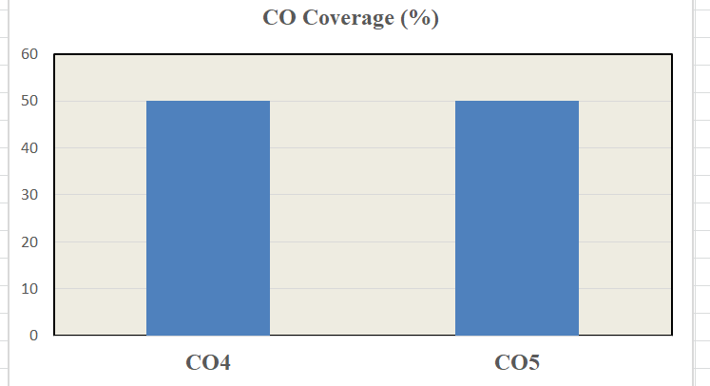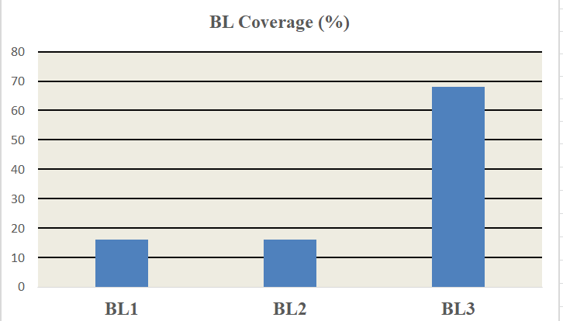

Approved by the Course Coordinator Signature of the Question paper setter

Evaluation Sheet
Name of the Student: Register No.:
Part- A (10x 1= 10 Marks)
Q. No | CO | PO | Maximum Marks | Marks Obtained | Total
1 | 4 | 1 | 1
2 | 4 | 1 | 1
3 | 4 | 2 | 1
4 | 4 | 1 | 1
5 | 4 | 1 | 1
6 | 5 | 4 | 1
7 | 5 | 4 | 1
8 | 5 | 1 | 1
9 | 5 | 1 | 1
10 | 5 | 4 | 1
Part - B (4 x 4 = 16 Marks)
11 | 4 | 1 | 4
12 | 4 | 2 | 4
13 | 4 | 2 | 4
14 | 5 | 1 | 4
15 | 5 | 2 | 4
16 | 5 | 4 | 4
Part - C (2 x 12 = 24 Marks)
17 (a) | 4 | 1 | 12
17 (b) | 4 | 1 | 12
18 (a) | 5 | 4 | 12
18 (b) | 5 | 4 | 12
Consolidated Marks:

PO | Maximum Marks | Marks Obtained
1
2
4
Total
CO | Maximum Marks | Marks Obtained
4
5
Total

Signature of Course Teacher

Signature of the Course Coordinator Signature of the Academic Advisor

